**APRV (Airway Pressure Release Ventilation) Guideline**

Suggested uses

Alternative therapy for moderate/severe ARDS where standard lung protective ventilation and prone ventilation have either failed or cannot be implemented

By ICM consultant request for a recognised indication

Indications

Second line ventilatory strategy in patients with ARDS

First line strategy in those at high risk of developing ARDS

Contra-indications

No absolute contra-indications

Relative contra-indications

- untreated pneumothorax

- severe haemodynamic instability

- significant emphysematous bullae disease

- untreated severe bronchospasm

Advantages

Lower peak airway pressure compared with volume directed modes

Limited adverse effects on cardiovascular function

Spontaneous breathing possible throughout the cycle

Decreased use of sedation

Potential elimination of neuromuscular blockade

Cautions

In conditions requiring deep sedation or neuromuscular blockade, the benefits of spontaneous breathing during APRV will be lost. It is best used in patients with maintained spontaneous respiratory drive and instituted early in the in the clinical course rather than as a rescue therapy.

Failure of therapy would be an inability to achieve an acceptable PaO2 with a reduced FiO2 within 12-24 hours of initiation OR unacceptable hypercapnia.

Auto-release

Auto-release limits the expiratory time to a desired percentage of peak expiratory flow (PEF) - typically kept to between 25-75% PEF.

A high percentage will result in a shorter expiratory time. This will effectively increase the ‘intrinsic PEEP’ and mean airway pressure, improving oxygenation.  
A low percentage will result in a longer expiratory time. This lowers the intrinsic PEEP but will increase minute volume and improve elimination of CO2.

**Set-up**

**Preparation**

Cuffed ETT in situ

Haemodynamic stability

Avoid paralysis

**Initial settings**

FiO2: same as current

P(high): same as previous plateau airway pressure (usually 20-30cmH2O)

P(low): always set at 0cmH2O

T(high): 3s*

T(low) max: 1s

Automatic tube compensation ON

Auto-release function ON

Expiratory flow to terminate at 75% of PEF

**Monitoring**

Monitoring of airway pressures and FiO2

Check measured T(low) – see appendix

Check %MVspon – see appendix

Optimise sedation

Check ABG 20-30minutes after set up

**Weaning**

Begins once a patient's spontaneous respiratory effort constitutes the majority of minute ventilation (%MVspon>50% of total minute ventilation) and FiO2 <0.5

Decrease P(high) by 2cmH2O  
AND increase T(high) by 1s

Aim to reduce P(high) to 14cmH2O and increase T(high) to 12s.

At this point, patient is essentially breathing spontaneously on CPAP and weaning can continue as per traditional CPAP.

**\*If using APRV as first-line ventilatory strategy, start with T(high) of 5s**

**Troubleshooting**

Hypoxaemia  
Increase P(high) by 2cmH2O up to max 30cmH2O

OR increase FiO2   
OR increase T(high) by 0.5-1.0s  
OR if T(high) ≥10s, increase auto-release percentage of PEF up to max 75%

Hypercapnia  
Permissive hypercapnia is a normal strategy when using APRV. Consider altering settings before patient becomes acidaemic, GCS deteriorates or arrhythmias develop.

Ensure patient is not over-sedated. The patient should ideally be making spontaneous respiratory effort.  
Increase P(high) by 2cmH2O up to max 30cmH2O

OR decrease auto-release percentage of PEF (NOTE this may worsen oxygenation, never lower below 25%)  
OR decrease T(high) 0.2-0.5s (NOTE this may worsen oxygenation)

Hypocapnia  
Increase T(high) by 0.2-0.5s  
OR decrease P(high) by 2cmH2O (NOTE this may worsen oxygenation)

OR increase auto-release percentage of PEF up to max 75%

Failure

Uncontrolled worsening hypercapnia may occur early

* More likely in patients with inadequate spontaneous respiratory effort
* Consider ending trial of APRV and re-attempting when sedation can be optimised to facilitate greater spontaneous respiratory effort

No improvement in oxygenation

* Improvement in P/F ratio typically seen in 12-24 hours
* Failure to see this should warrant consideration of continuing or ending trial of APRV

References

Frawley PM, Habashi NM. Aiway Pressure Release Ventilation Theory and Practice. *AACN Clin Issues* 2001; 12(2):234-246

Habashi NM. Other approaches to open-lung ventilation: Airway Pressure Release Ventilation. *Crit Care Med* 2005; 33(Supp): S228-40

APRV network. Setting APRV using the TCAV Method as a Rescue Strategy. https://www.aprvnetwork.org/. Accessed April 2020

**Appendix**

Auto-release

Auto-release sets the expiratory time to a desired percentage of peak expiratory flow.

A high percentage will result in a shorter expiratory time. This effectively increases the ‘intrinsic PEEP’ and mean airway pressure. A low percentage results in a longer expiratory time, lowering intrinsic PEEP but increasing minute ventilation and CO2 elimination.

1. In Additional settings, select auto-release

3. Select on and confirm  
4. Select 75% initially (this can then be adjusted from 25-75%)

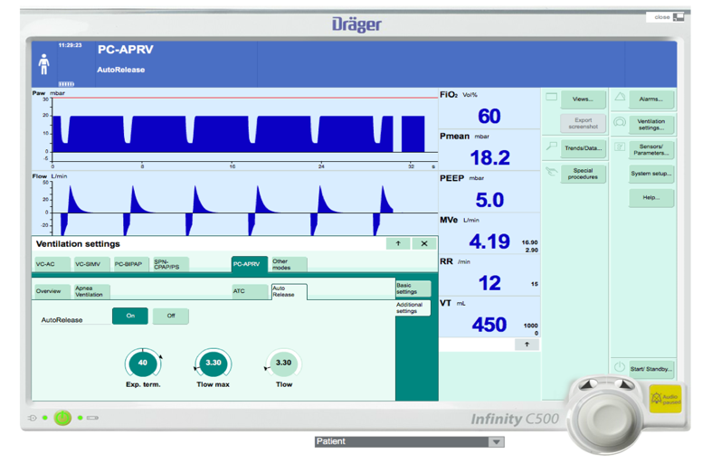

Monitoring values

**T(low)**

With auto-release on we recommend keeping T(low) max at 1s. Delivered T(low) is measured by the ventilator and can be found under ‘Values’ tab. If delivered T(low) matches T(low) max then lowering auto-release PEF will have no impact. To extend T(low) time further, T(low) max will need to be increased.

If this is required, patient should be examined to ensure there is no significant bronchospasm or obstruction to expiration.

**%MVspon**

Spontaneous respiration is possible and beneficial in APRV. In the ‘Values’ tab you can see the measured percentage of minute ventilation which is a result of spontaneous breathing.

If safe to do so, sedation should be optimised to maximise this value. Weaning ideally requires %MVspon>50%.

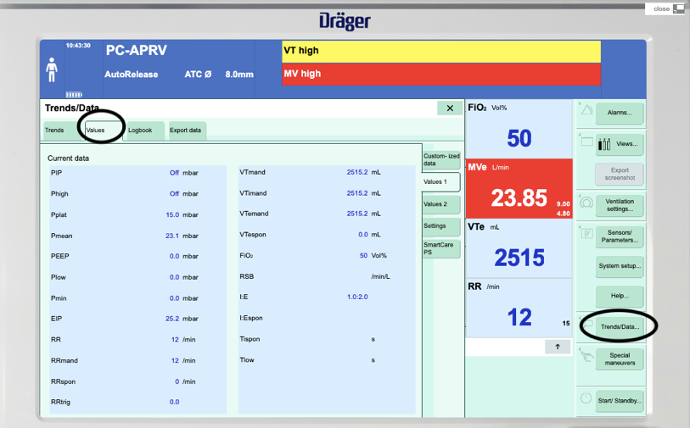

|  |  |
| --- | --- |
| **Title:** APRV (Airway Pressure Release Ventilation) Guideline | |
|  | **Authors:** A. Abu-Arafeh and M. Blackstock |
| **Status Draft/Final:** Final | **Approved by:** QIT editorial group |
|  | **Written:** May 2020 |
| **Reviewed on:** May 2020 | **Next Review:** May 2022 |